LEARNER GUIDE
For
Sustainability Reporting Masterclass
Course Code: C797
Conducted by
Tertiary Infotech Academy Pte Ltd.
UEN: 201200696W
Version 1.0
Effective date: 01 Oct 2026

Document Version Control Record
Version | Effective Date | Changes | Author
1.0 | 01 Oct 2026 | First version of the Sustainability Reporting Masterclass learner guide: course overview, learning outcomes and four activity procedures. | Tertiary Infotech Academy

Table of Contents
Document Version Control Record 2
Table of Contents 3
Course Overview 5
Learning Outcomes 5
How to use the course activities 5
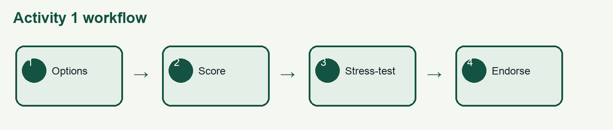
Activity 1 — Engineering solution option appraisal 6
Goal 6
Step 1 6
Step 2 6
Step 3 6
Step 4 6
Step 5 6
Step 6 6
Test it 6
Acceptance checks 6
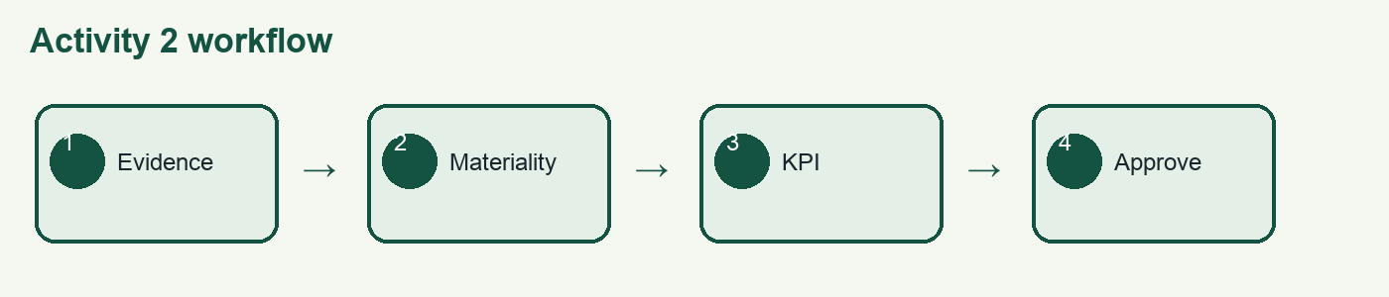
Activity 2 — ESG materiality and strategic scorecard 7
Goal 7
Step 1 7
Step 2 7
Step 3 7
Step 4 7
Step 5 7
Step 6 7
Test it 7
Acceptance checks 7
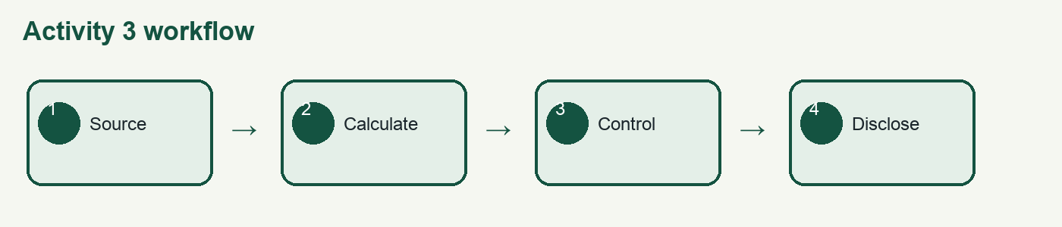
Activity 3 — Disclosure control and compliance crosswalk 8
Goal 8
Step 1 8
Step 2 8
Step 3 8
Step 4 8
Step 5 8
Step 6 8
Test it 8
Acceptance checks 8
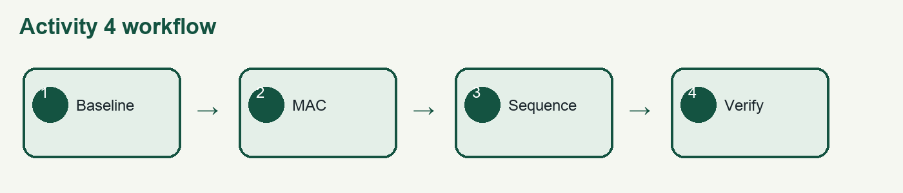
Activity 4 — Circularity and decarbonisation portfolio 9
Goal 9
Step 1 9
Step 2 9
Step 3 9
Step 4 9
Step 5 9
Step 6 9
Test it 9
Acceptance checks 9
References 9

Course Overview
This two-day course helps senior leaders connect engineering decisions to defensible sustainability disclosures, regulatory compliance and market positioning. Duration is 15 instructional hours over 2 days (9:30am – 5:30pm).

Learning Outcomes
Learning unit | Applied outcome
LU1: Foundations of Sustainability and ESG | Review and endorse engineering solutions using an evidence-based option appraisal.
LU2: ESG Strategy, Stakeholder Engagement, and Market Positioning | Develop a material ESG strategy and benchmark it against peers and prevailing trends.
LU3: Sustainability Reporting, ESG Disclosure, and Compliance | Build a disclosure-ready evidence chain and compliance crosswalk for IFRS S1/S2, GRI and SGX.
LU4: Circular Economy, Sustainable Supply Chains, and Carbon Reduction Strategies | Propose a competitive circular and decarbonisation portfolio with ecological and communal benefits.

How to use the course activities
Work in the provided activity folder. Start with README.md, use the mock data as the common fact base, record assumptions, and cite evidence in the decision template. The PDF copy is available for print; the Markdown copy is the editable source. Do not use completed learner records as examples.

Activity 1 — Engineering solution option appraisal

Goal
Produce a reproducible executive decision record grounded in the supplied mock data and official reference brief.

Step 1
Open activities/activity-01-engineering-option-appraisal/mock-data/mock-data.csv and confirm CAPEX, annual savings, reductions, readiness and risk fields.

Step 2
Calculate simple payback = CAPEX ÷ annual savings. Keep the unit in years.

Step 3
Use WORKSHEET.md to normalise each criterion to a 1–5 score and apply the stated weights.

Step 4
Compute weighted score = Σ(score × weight). Check that weights total 100%.

Step 5
Stress-test the recommendation by shifting 10 percentage points from payback to carbon.

Step 6
Complete decision-template.md with endorsed option, conditions, evidence gaps, owner and review date.

Test it
Exchange the completed decision record with another group. They must reproduce the result from the cited files, explain the threshold, and identify the same residual uncertainty. Revise any step they cannot reproduce.

Acceptance checks
All formulas reconcile; assumptions are labelled; evidence sources are named; decision thresholds are explicit; a reviewer can reproduce the result; the conclusion states residual uncertainty.

Activity 2 — ESG materiality and strategic scorecard

Goal
Produce a reproducible executive decision record grounded in the supplied mock data and official reference brief.

Step 1
Open activities/activity-02-materiality-scorecard/mock-data/mock-data.csv and label each item by stakeholder, issue and reliability.

Step 2
Rate stakeholder significance and enterprise impact from 1–5 using WORKSHEET.md.

Step 3
Plot issues on the 5×5 materiality matrix and flag the ≥4/≥4 priority zone.

Step 4
Calculate confidence-adjusted priority = significance × impact × reliability ÷ 5.

Step 5
Build four KPIs with definition, baseline, target, owner, source system, review cadence and tolerance.

Step 6
Record strategic choices in decision-template.md and identify one trade-off requiring approval.

Test it
Exchange the completed decision record with another group. They must reproduce the result from the cited files, explain the threshold, and identify the same residual uncertainty. Revise any step they cannot reproduce.

Acceptance checks
All formulas reconcile; assumptions are labelled; evidence sources are named; decision thresholds are explicit; a reviewer can reproduce the result; the conclusion states residual uncertainty.

Activity 3 — Disclosure control and compliance crosswalk

Goal
Produce a reproducible executive decision record grounded in the supplied mock data and official reference brief.

Step 1
Open activities/activity-03-disclosure-control/mock-data/mock-data.csv and flag missing owners, unsupported estimates and stale records.

Step 2
Trace each metric from source record to calculation, approval and disclosure line.

Step 3
Use references/SOURCES.md to map evidence to IFRS S1/S2, GRI and SGX.

Step 4
Calculate control risk = likelihood × disclosure impact; escalate scores ≥15.

Step 5
Design a control with owner, frequency, input, action, retained evidence and escalation threshold.

Step 6
Complete decision-template.md and state the assertion boundary and limitation.

Test it
Exchange the completed decision record with another group. They must reproduce the result from the cited files, explain the threshold, and identify the same residual uncertainty. Revise any step they cannot reproduce.

Acceptance checks
All formulas reconcile; assumptions are labelled; evidence sources are named; decision thresholds are explicit; a reviewer can reproduce the result; the conclusion states residual uncertainty.

Activity 4 — Circularity and decarbonisation portfolio

Goal
Produce a reproducible executive decision record grounded in the supplied mock data and official reference brief.

Step 1
Open activities/activity-04-circular-decarbonisation/mock-data/mock-data.csv and confirm the reporting boundary.

Step 2
Separate negative annual cost (saving) from positive annual cost.

Step 3
Calculate marginal abatement cost = net annual cost ÷ tCO2e avoided.

Step 4
Compare with the official 2026–2027 Singapore carbon-tax context in references/SOURCES.md.

Step 5
Sequence no-regret, enabling and transformation initiatives with dependencies and evidence gates.

Step 6
Complete decision-template.md with ecological benefit, community impact, commercial value, owners and verification plan.

Test it
Exchange the completed decision record with another group. They must reproduce the result from the cited files, explain the threshold, and identify the same residual uncertainty. Revise any step they cannot reproduce.

Acceptance checks
All formulas reconcile; assumptions are labelled; evidence sources are named; decision thresholds are explicit; a reviewer can reproduce the result; the conclusion states residual uncertainty.

References
- IFRS Foundation — IFRS S1 and IFRS S2: https://www.ifrs.org/issued-standards/ifrs-sustainability-standards-navigator/
- Global Reporting Initiative Standards: https://www.globalreporting.org/standards/
- Singapore Exchange sustainability reporting: https://www.sgx.com/regulation/sustainability-reporting
- Greenhouse Gas Protocol standards: https://ghgprotocol.org/standards-guidance
- United Nations Sustainable Development Goals: https://sdgs.un.org/goals
- Singapore Green Plan 2030: https://www.greenplan.gov.sg/

